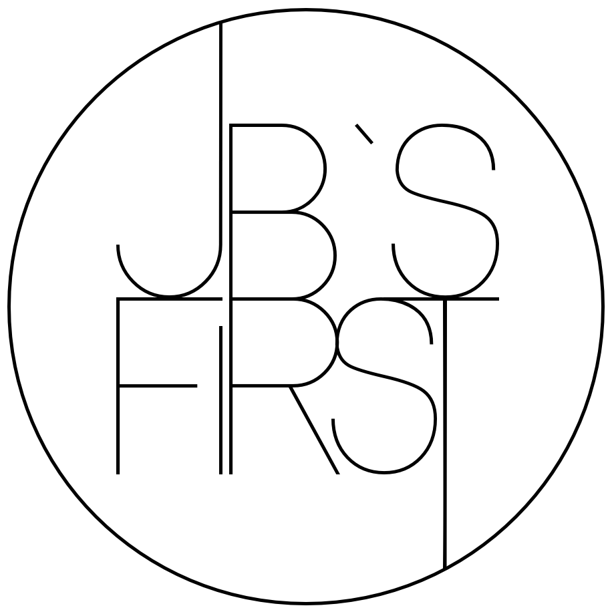
Press text // Bio // Links // Press reviews

⇒ Information on the correct spelling of the band name

JB`S FIRST

Please write the band name only with capital letters and the correct apostrophe.

The correct spelling helps people to find the concert, your location / festival at which we play better in the internet and to recognize the band name at first sight. In return, we also take care to spell and present your festival / location name correctly. Thank you very much!

⇒ Press text

---
JB'S FIRST is an electrifying groove-pop band. Their upcoming EP “My Time” is a unique fusion of pop, funk, rock, and soul, following in the footsteps of music legends such as Nikka Costa, Jamiroquai, and Lenny Kravitz.
The band, led by charismatic singer Kathi Bestler, consists of a powerhouse of musicians who deliver tight grooves and infectious melodies. JB'S FIRST showcases their musical talent as songwriters in all of their original compositions. Each song conveys an emotional story that deeply touches the listener. “My Time” gives you anthems about love and empowerment, as well as groovy hooks that will get you addicted.
---
---
JB`S FIRST is an electrifying band that has a unique blend of pop, funk, rock, and soul. Their groove-pop is a mesmerizing fusion that draws inspiration from musical legends like Nikka Costa, Jamiroquai and Lenny Kravitz resulting in a sonic experience that is both fresh and timeless. Fronted by the charismatic Kathi Bestler, the band boasts a powerhouse of musicians who deliver tight grooves and infectious melodies. Their songwriting prowess shines through in their original and own compositions. Each track telling a compelling story with lyrics that resonate deeply with listeners. From anthems of love and empowerment to groovy tunes that will get you addicted.

---

⇒ Bio

JB`S FIRST was founded in 2003 by Kathi Bestler, Patric Eckstein and Sarah Dorsel (retired in 2013).

CURRENT LINE-UP
Kathi Bestler (vocals)
Patric Eckstein (guitar)
Benny Kottmair (eys)
Andi Stocker (bass)
Sascha Ibel (drums)

DISCOGRAPHIE
LITTLE WORLD (2016)
To The TOP (2008)
The FIRST (2006)

FACTS:
- Over 200 concerts played in Germany and Austria
- Release of three studio albums
- Soundtrack for various film productions
- Awards and music prizes (Hofer Song Contest “Special Jury Prize” for the song “Between The Lines”; Sprungbrett “Best Newcomer Band” 2007; Muc-King “Best Munich Newcomer Band” 2006)
- An integral part of the Young Gasteig series for the 25th anniversary of the Gasteig Munich

⇒ Links

PHOTOS
Please only use the photos provided by us under this link. Thanks!
www.jbs-first.de/booking

SOCIAL MEDIA
- Website www.jbs-first.de
- Instagram www.instagram.com/jbs_first
- Facebook www.facebook.com/jbsfirst
- Youtube www.youtube.com/user/JBsFIRST

STREAMING
- Spotify https://open.spotify.com/intl-de/artist/7rM77ac3pI3oxeXE5Ye0Gd?si=9UHj3t9_SVGzoZuJdxPa7A
- Apple Music https://music.apple.com/de/artist/jbs-first/1723404252
- Tidal https://tidal.com/artist/44736187
- Amazon https://www.amazon.de/music/player/artists/B0CR5TLMH7/jb's-first

VIDEOS
You are welcome to use the following videos for advertising purposes. If you need them as a file, please send us an email. Thanks!

- Booking Video: https://www.youtube.com/watch?v=0wqRSllpNzM
- LITTLE WORLD (off. video): https://www.youtube.com/watch?v=WY6KlSmaTKM
- Live Snippet: https://www.youtube.com/watch?v=qdD_dYcPHW

⇒ Press reviews

...driving disco beats, rocking power play and electronic hook melodies with unmistakable groove power..." (Süddeutsche Zeitung)

"...right from the first song the mood was at its maximum and didn`t let up after that. Powerful, sensitive, melodic, sympathetic, to the point...The song arrangements proved international quality and gave the powerful voice of lead singer Kathi Bestler room to unfold to its full potential..." (Chocolate Music)

"...the groove and Kathi Bestler`s impassioned vocals set the tone..." (TZ)

"...the Munich band JB`S FIRST dives into a sound pool of funk, soul and pop at the Theatron..." (Süddeutsche Zeitung)

